From: http://www.spectator.co.uk/2015/11/i-was-tossed-out-of-the-tribe-climate-scientist-judith-curry-interviewed/

‘I was tossed out of the tribe’: climate scientist Judith Curry interviewed

For engaging with sceptics, and discussing uncertainties in projections frankly, this Georgia professor is branded a heretic
David Rose
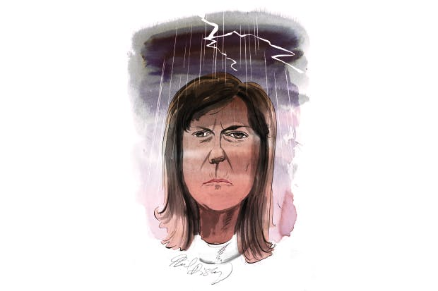
David Rose
28 November 2015
9:00 AM

It is safe to predict that when 20,000 world leaders, officials, green activists and hangers-on convene in Paris next week for the 21st United Nations climate conference, one person you will not see much quoted is Professor Judith Curry. This is a pity. Her record of peer-reviewed publication in the best climate-science journals is second to none, and in America she has become a public intellectual. But on this side of the Atlantic, apparently, she is too ‘challenging’. What is troubling about her pariah status is that her trenchant critique of the supposed consensus on global warming is not derived from warped ideology, let alone funding by fossil-fuel firms, but from solid data and analysis.
Some consider her a heretic. According to Professor Michael Mann of Pennsylvania State University, a vociferous advocate of extreme measures to prevent a climatic Armageddon, she is ‘anti-science’. Curry isn’t fazed by the slur.
‘It’s unfortunate, but he calls anyone who doesn’t agree with him a denier,’ she tells me. ‘Inside the climate community there are a lot of people who don’t like what I’m doing. On the other hand, there is also a large, silent group who do like it. But the debate has become hard — especially in the US, because it’s become so polarised.’ Warming alarmists are fond of proclaiming how 97 per cent of scientists agree that the world is getting hotter, and human beings are to blame. They like to reduce the uncertainties of climate science and climate projections to Manichean simplicity. They have managed to eliminate doubt from what should be a nuanced debate about what to do.
Professor Curry, based at the Georgia Institute of Technology in Atlanta, does not dispute for a moment that human-generated carbon dioxide warms the planet. But, she says, the evidence suggests this may be happening more slowly than the alarmists fear.
In the run-up to the Paris conference, said Curry, much ink has been spilled over whether the individual emissions pledges made so far by more than 150 countries — their ‘intentional nationally determined contributions’, to borrow the jargon — will be enough to stop the planet from crossing the ‘dangerous’ threshold of becoming 2°C hotter than in pre-industrial times. Much of the conference will consist of attempts to make these targets legally binding. This debate will be conducted on the basis that there is a known, mechanistic relationship between the concentration of carbon dioxide in the atmosphere and how world average temperatures will rise.
Unfortunately, as Curry has shown, there isn’t. Any such projection is meaningless, unless it accounts for natural variability and gives a value for ‘climate sensitivity’ —i.e., how much hotter the world will get if the level of CO2 doubles. Until 2007, the UN Intergovernmental Panel on Climate Change (IPCC) gave a ‘best estimate’ of 3°C. But in its latest, 2013 report, the IPCC abandoned this, because the uncertainties are so great. Its ‘likely’ range is now vast — 1.5°C to 4.5°C.
This isn’t all. According to Curry, the claims being made by policymakers suggest they are still making new policy from the old, now discarded assumptions. Recent research suggests the climate sensitivity is significantly less than 3˚C. ‘There’s growing evidence that climate sensitivity is at the lower end of the spectrum, yet this has been totally ignored in the policy debate,’ Curry told me. ‘Even if the sensitivity is 2.5˚C, not 3˚C, that makes a substantial difference as to how fast we might get to a world that’s 2˚C warmer. A sensitivity of 2.5˚C makes it much less likely we will see 2˚C warming during the 21st century. There are so many uncertainties, but the policy people say the target is fixed. And if you question this, you will be slagged off as a denier.’
Curry added that her own work, conducted with the British independent scientist Nic Lewis, suggests that the sensitivity value may still lower, in which case the date when the world would be 2˚C warmer would be even further into the future. On the other hand, the inherent uncertainties of climate projection mean that values of 4˚C cannot be ruled out — but if that turns out to be the case, then the measures discussed at Paris and all the previous 20 UN climate conferences would be futile. In any event, ‘the economists and policymakers seem unaware of the large uncertainties in climate sensitivity’, despite its enormous implications.
Meanwhile, the obsessive focus on CO2 as the driver of climate change means other research on natural climate variability is being neglected. For example, solar experts believe we could be heading towards a ‘grand solar minimum’ — a reduction in solar output (and, ergo, a period of global cooling) similar to that which once saw ice fairs on the Thames. ‘The work to establish the solar-climate connection is lagging.’
Curry’s independence has cost her dear. She began to be reviled after the 2009 ‘Climategate’ scandal, when leaked emails revealed that some scientists were fighting to suppress sceptical views. ‘I started saying that scientists should be more accountable, and I began to engage with sceptic bloggers. I thought that would calm the waters. Instead I was tossed out of the tribe. There’s no way I would have done this if I hadn’t been a tenured professor, fairly near the end of my career. If I were seeking a new job in the US academy, I’d be pretty much unemployable. I can still publish in the peer-reviewed journals. But there’s no way I could get a government research grant to do the research I want to do. Since then, I’ve stopped judging my career by these metrics. I’m doing what I do to stand up for science and to do the right thing.’
She remains optimistic that science will recover its equilibrium, and that the quasi-McCarthyite tide will recede: ‘I think that by 2030, temperatures will not have increased all that much. Maybe then there will be the funding to do the kind of research on natural variability that we need, to get the climate community motivated to look at things like the solar-climate connection.’ She even hopes that rational argument will find a place in the UN: ‘Maybe, too, there will be a closer interaction between the scientists, the economists and policymakers. Wouldn’t that be great?’
David Rose writes for the Mail on Sunday.

